**Escape Dungeon VR**

Escape Dungeon is a simple point and click puzzle game which I created as part of my Udacity nanodegree Term2 coursework. In this game, the user is trapped in an abandoned dungeon without knowing how. The only way to escape is by repeating an audio visual sequence of orbs played.

**Video:** https://www.youtube.com/watch?v=D9wLfHLrEFM

**WORK FLOW**

Statement of Purpose: Escape Dungeon is a VR app for Google cardboard and it provides an easy fun way to increase the alertness of mind and eye coordination by challenging the user to solve a simple puzzle through repeating an audio visual sequence.

Target User:

* Working professional within office hours looking for a fun way to alert mind yet relax
* I wanted to make the app friendly to people who are near sighted and / or have color blindness(red and green specifically) as a majority of people these days have weak eyesight and so after some research found out that people are interested in apps which they can see even without glasses on their face. Also the app would provide a fun way to move the eye ball thereby helping to relax eye muscles.
* Beginner to medium VR experience

So I chose the users accordingly for testing out my project from time to time:

Persona1 example:

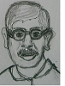 Sam: 40, Banker

*“Looking for a fun way to relax my mind and keep myself alert while working”*

Sam works in a senior role in a bank. His office hours and work is pretty demanding and so has absolutely no time for relaxing.

Sam is interested in apps that would help take his mind away occasionally from work and yet be challenging enough to keep him alert so as to enable him to focus more on his work. He is near sighted and color blind (red and green) so is looking for an app that will make him focus on things other than staring at computer screen. He is hoping that without glasses he should be able to focus on roughly a distance of till 2 m. He would like to relax without his glasses on his face once in a while. Also he’s looking for an app which helps to relax his eye muscles.

VR experience: Beginner

Low Fidelity Prototypes:

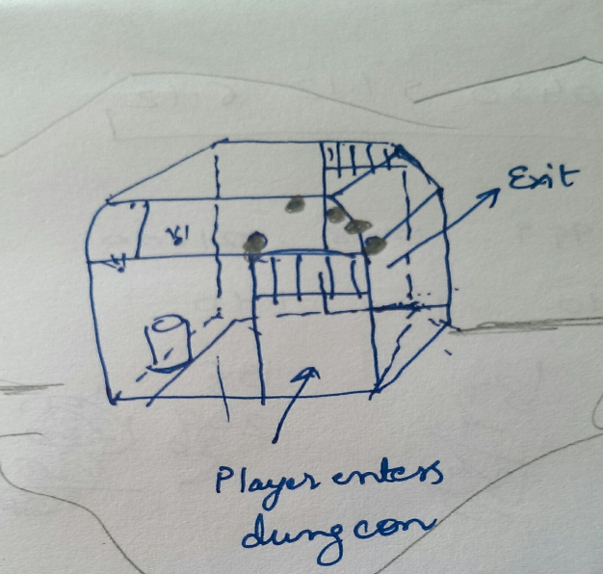

***Abandoned dungeon in the middle of mountains.***

***Player enters the dungeon, solves the puzzle and exits the dungeon with a choice to restart the game.***

Design considerations (Final choice after some user testing):

* Is the user seated/ standing when experiencing the VR?

Assumed a standing experience for the user

* Defining viewing angles and distance for UI, Font style, color and text :

Since I wanted to make the app friendly for people who are nearsighted and red and green color blind, so I decided to go with the below :

***Start UI, Inside Dungeon UI and Restart UI***: 2m, 3m and 4m respectively from user. All the UIs to be placed in such a manner that they are not obscuring any views.

***Font type:*** Arial, Bold for clear viewing

***Font color:***

**Button:** Black font color against white background for clear view,

**UI Panels:**White text against black/clear background

**Error message:** Red against black dark grey background.

* Orb placement: I decided to place the orbs head on in semicircular fashion so that the user has no difficulty seeing them and do not involve much head turning.

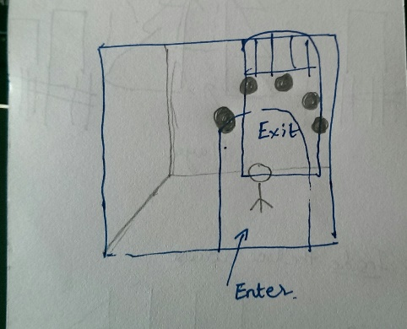

Had to get some user testing on the placement of orbs and distance between the orbs so that the user shouldn’t have to watch up and down while choosing the orbs.

* Defining Content - introductory text and error messages

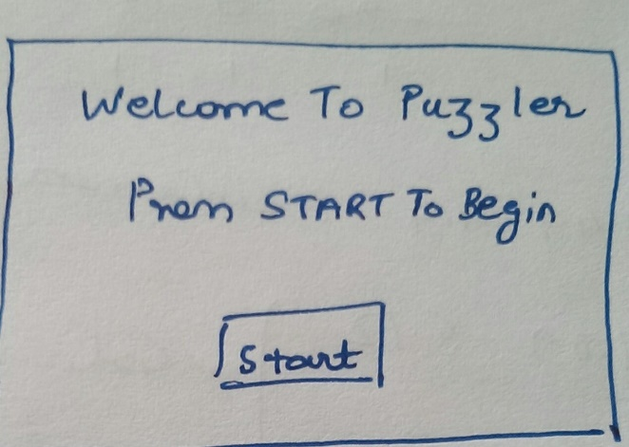

User testing, Outcomes & Iteration:

User testing was conducted with 2 users on the below points:

Scale testing:

User feedback: Door height low, users felt as if they might hit their head the top of entry wall.

Changes: Rescaled the door height, compared the height against a unit cube and placing Ethan next to it to compare the average height of person. Had to do 3-4 iterations to get the gates scaled right before building on the dungeon ceiling and walls.

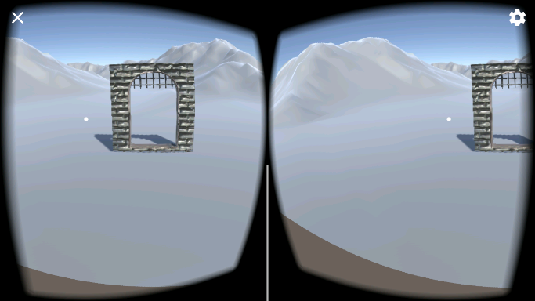

Mood and Lighting:

Users were comfortable with the mood and compared it to an eerie feeling, lighting was low and had that abandoned feel to it. I had added soft shadows from the point lights to give to a real feel. Although they suggested I should add flames to the torches to make it real.

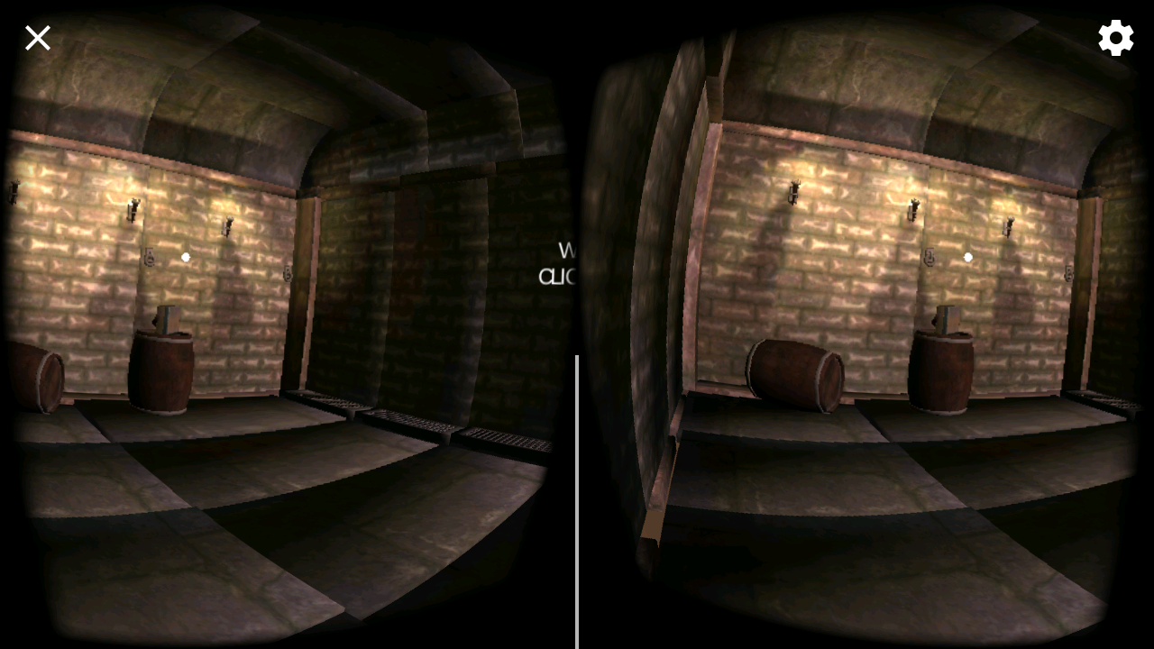

UI testing and content: I had to do around 4-5 iterations with the content, font size and color of the introductory text, error message and the help instructions to make it clear.

User Feedback: Introductory text and the help instructions were not obvious enough for beginners who are new to VR.

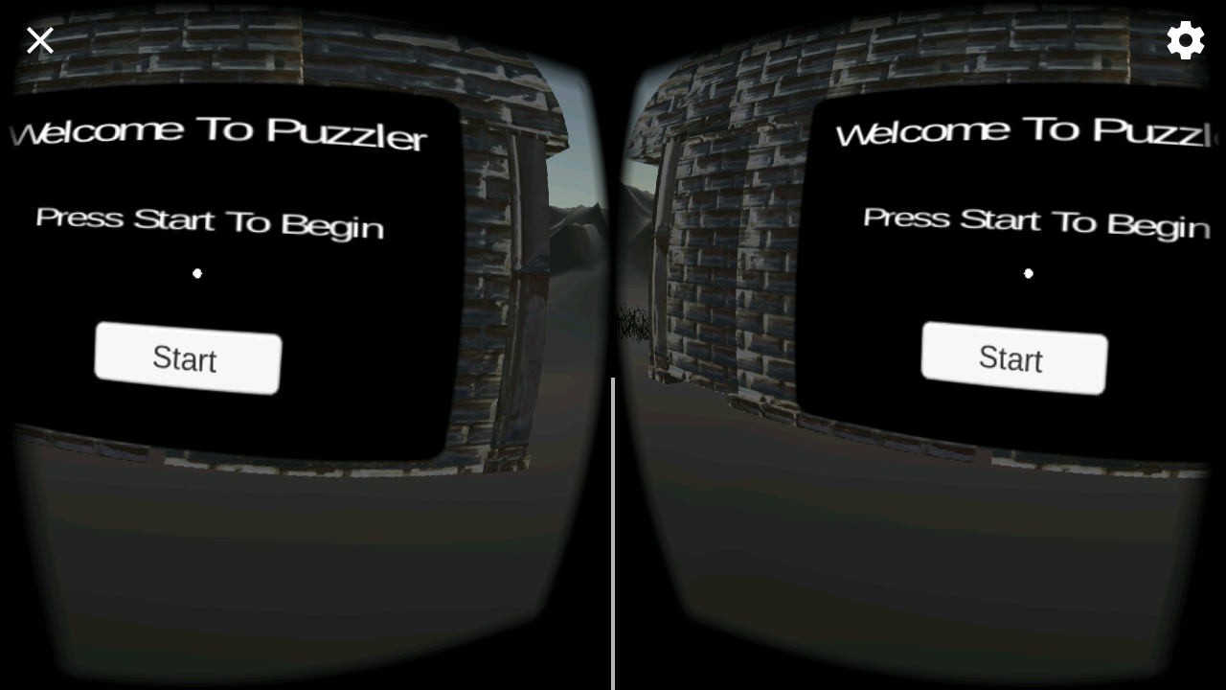

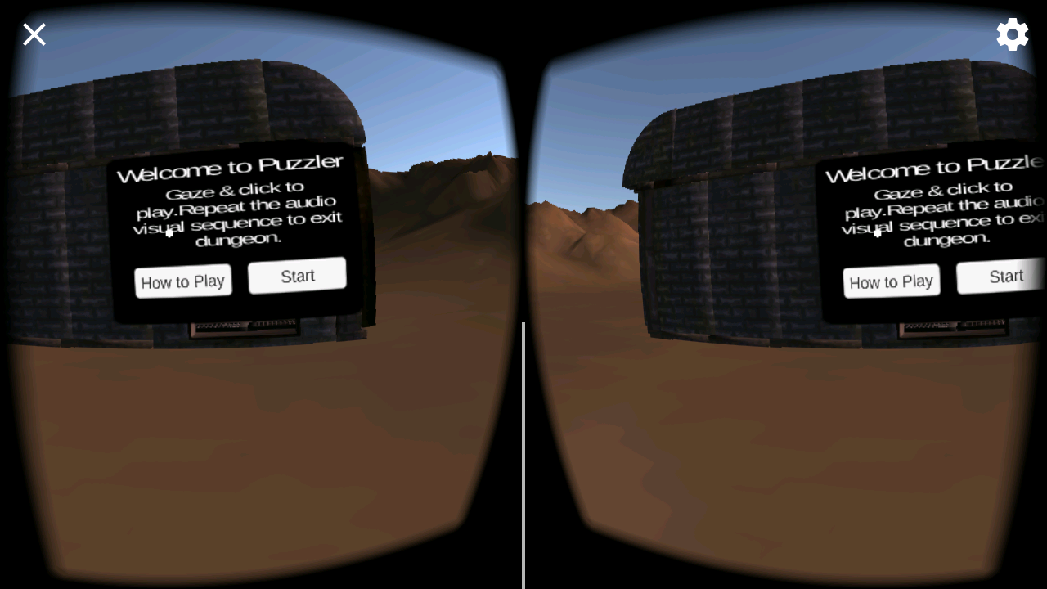

Final Outcome: After a couple of iterations, the final content and the game playing rules.

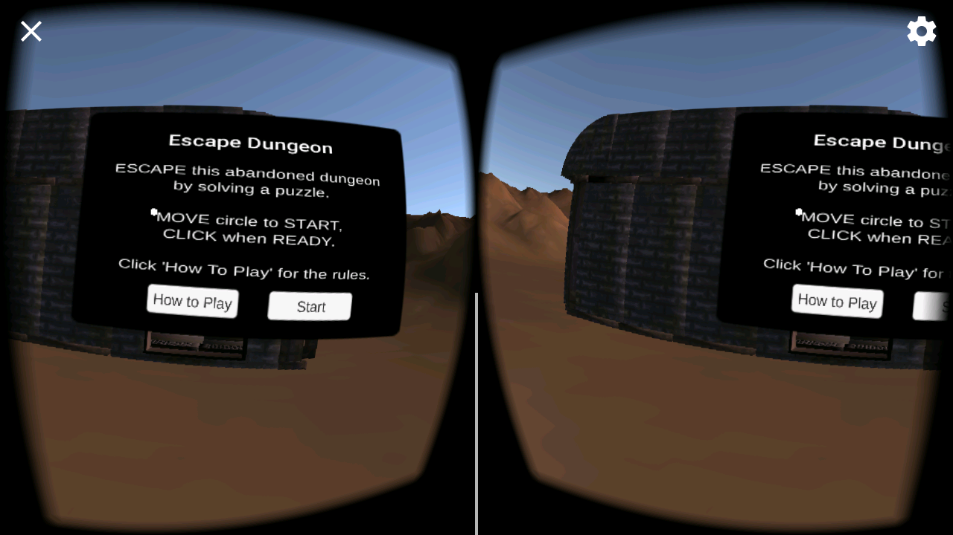

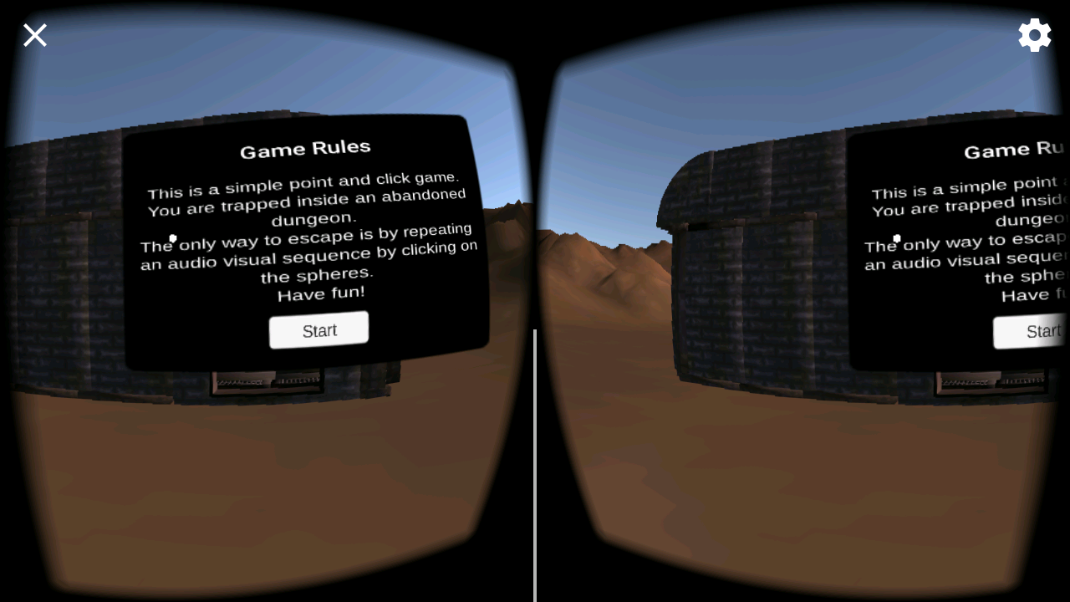

Audio Visual Testing:

User Feedback: Audio is loud. Orb sound low compared to background sound.

Changes were made appropriately.

Game & Motion Mechanics:

User feedback:

* No way to quit the game.
* When user enters dungeon, game starts playing immediately, user should get time to be comfortable with the surroundings before the puzzle begins.
* No message for wrong selection in sequence.
* Users were quite happy with the speed of the game and complained of no dizziness.

Changes: I made the “X” functional to quit the application, introduced a text in the play area before the puzzle begins, and added error message for wrong sequence being played.

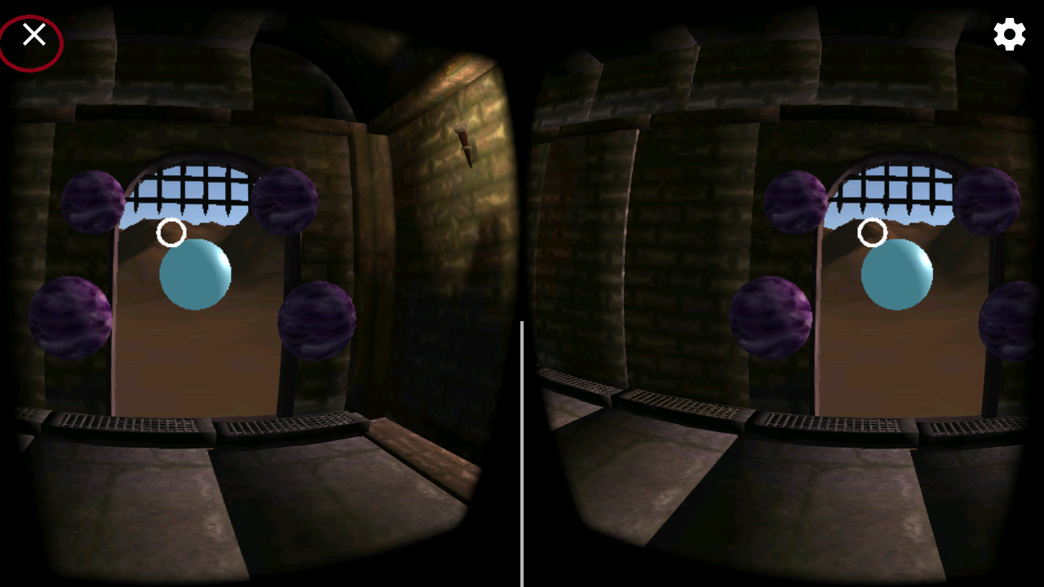

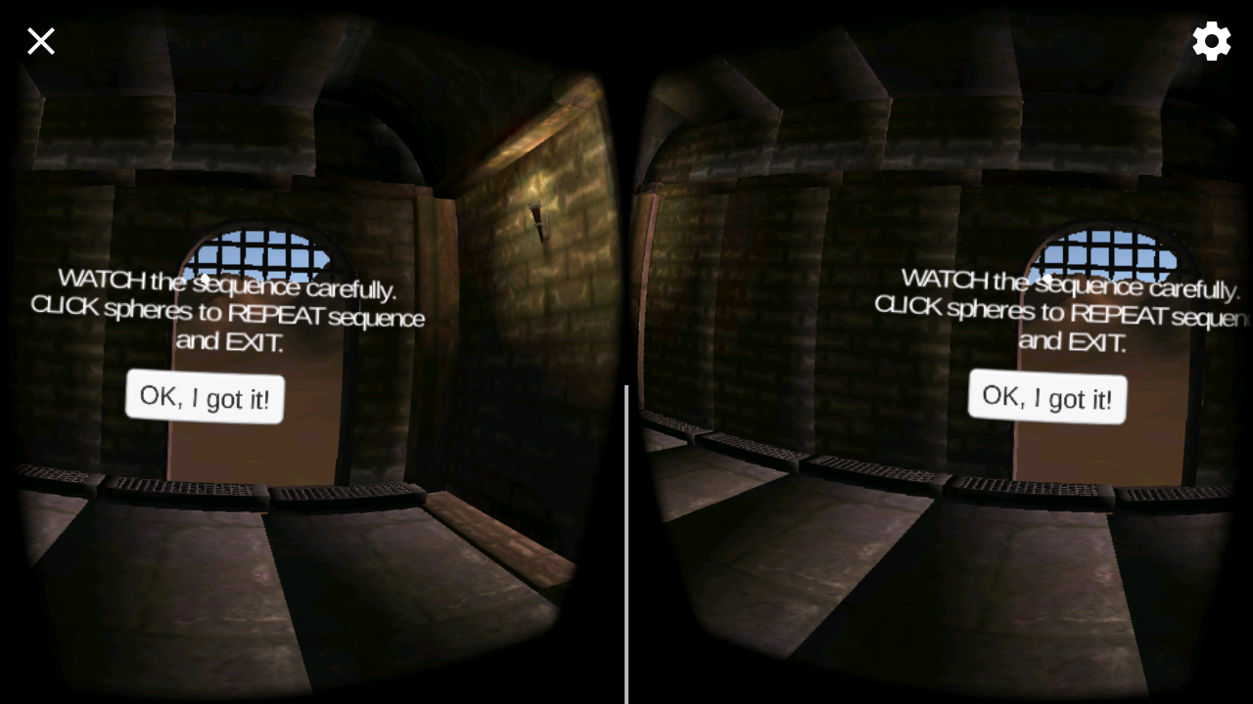

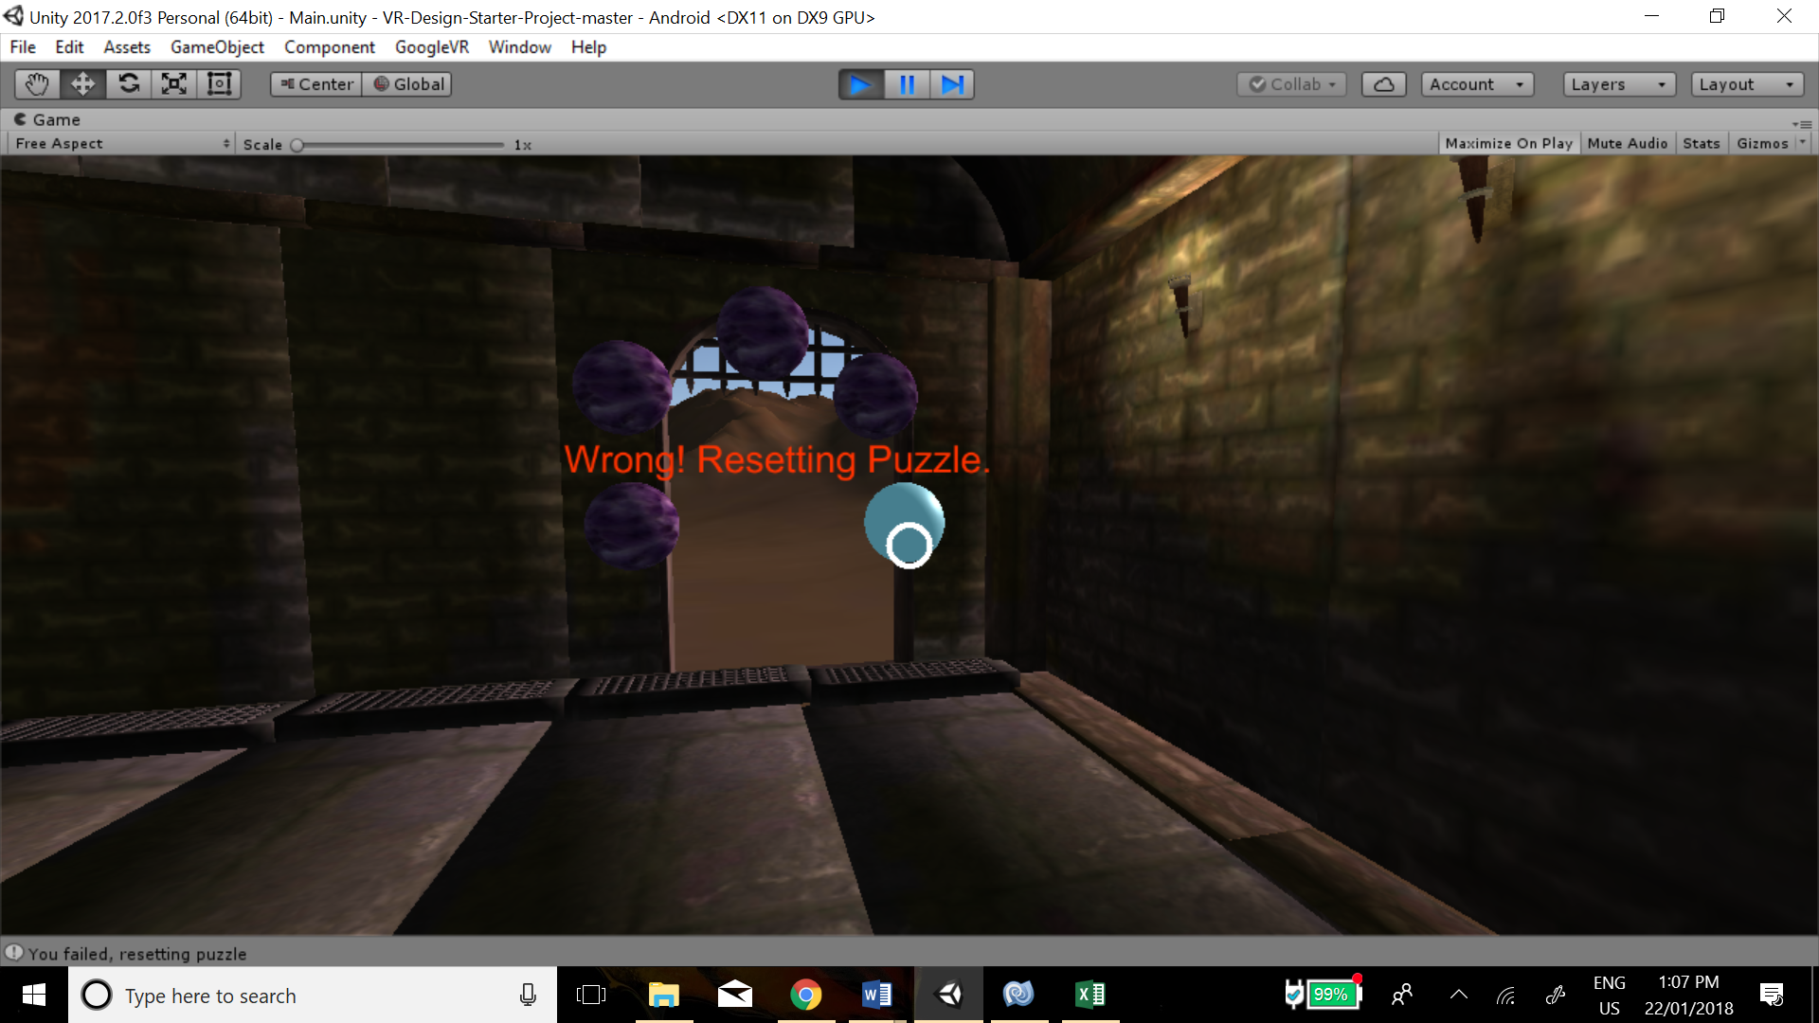

**Breakdown of final piece:**

My main focus while building this game was to create a simple UI and scene with clear instructions for VR beginners and people who are color blinded (targeted red green) or near sighted. The choice of colour of font and the UI panels particularly was challenging and after few user testing iterations, I settled with white text against clear background inside the dungeon and outside kept it to white text against black background. Similarly for the buttons choice of black text in white background seemed to give good results.

To make the game engaging and to alert mind and increase eye coordination, I added different piano notes on each orb click. I had a good success with all my users being able to complete the puzzle with ease, especially the combination of audio with visual sequence made the game engaging and fun to play.

**Conclusion and Next Steps:**

I learnt a great deal from this project thanks to my mentor and other forum mentors. I learnt about the design considerations one must focus on before starting as well as during the entire development process.

My next steps would be to add more levels and timeout to make the puzzle challenging and adding few DISTRACTIONS within the dungeon scene so that it becomes difficult for the user to focus while playing.